**Scripting Task**

1. Create a shell script to print the HTTP error code of guvi.in & print, the success/failure message based on the error code response
2. The new shell script is created in the VS editor and named the file **status check.sh**
3. HTT**P Status codes are 200 – Success, 404-Not found, 500-Internal server error.** **Curl** command is used since the data associated is http based.
4. Script is written as below

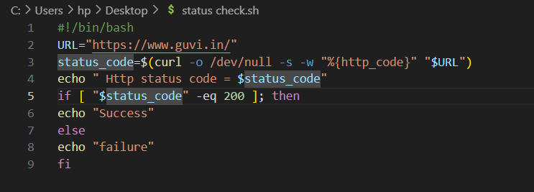

1. Explanation :

I) Followed by shebang, The url of the guvi website is assigned to the **URL** variable.

2) In the status_code variable, **curl** is used with certain options like to ignore the html content **(-o /dev/null)**, to run in a silent manner without showing error or progress **(-s)** and to display only the http error code of the guvi **website ( -w “%{http_code}”).**

3) The **$URL** is used at the end of the curl to get the data from the url stored in the URL variable.

4) **echo** is used to print the http code and if condition is used to describe that if the status code is equal to 200, success will be printed or failure will be printed.

E. In the terminal, check the location of the sh file using **pwd** and using **cd**, go to the location of the file .

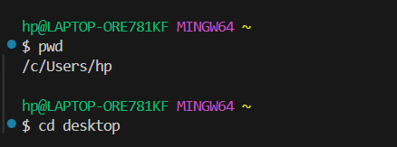

1. Run the file with **“./status check.sh”**.

The following output is displayed. Since the status code is 200, the success message is printed.

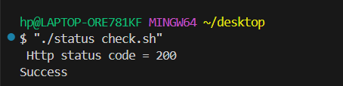

1. Given a file, replace all occurrence of the word "give" with "learning" from 5th line till the end in only those lines that contain the word "welcome".
2. Initialy, created a file with **vi** command and gone into insert mode by pressing **i.** given the sample content as below and saved the file using **:wq**.

Sample content : This is the first line.

This is the second line.

This is the third line.

This is the fourth line.

Welcome to the wonderful world.

It’s great to see you here!

Have a great day, welcome!

File name : **input.txt**

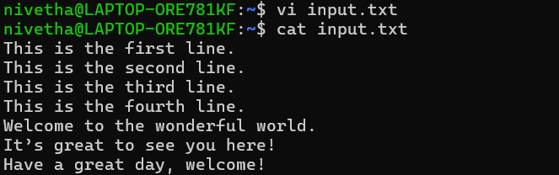

Created another file named **output.txt.**



1. Script is written as below:

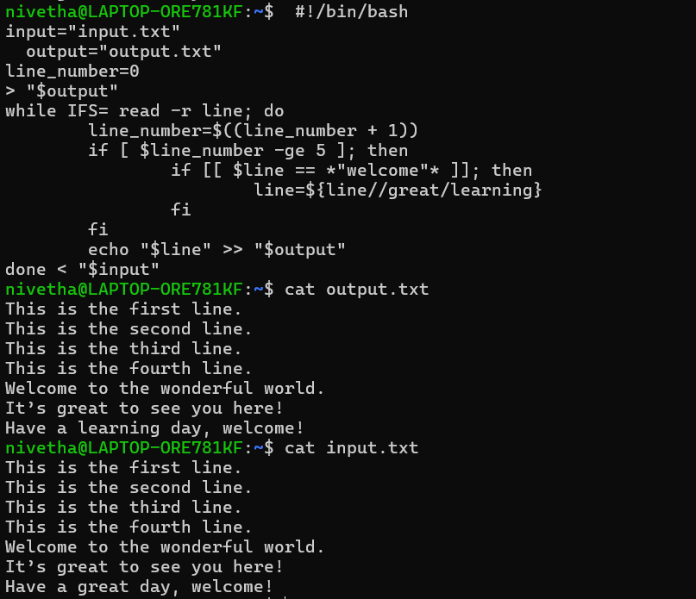

Explanation:

1. The input and output files are created which is defined by the variable
2. The line number keep track of the processing current line
3. While loop reads the input file line by line, **IFS** helps to prevent the diminishing of the space and **r** allows to read the file fully.
4. The line number increases and iteration happens.
5. If the current line number greater than or equal to 5, it will proceed to check whether the line item has “welcome” in it.
6. Upon satisfying above condition, great will be replaced with learning.
7. Then, **echo** is used to append the modified lines along with the unmodified one in to the new output file.
8. **> “$output”** is used the delete the contents it has before appending.
9. Now that output is displayed as above which satisfies the condition provided.